Mammography Tab User Guide

The Mammography Tab uses the BI-RADS classification to add images, DICOMS and define the mammography findings. This tab will only display for cases with a subspecialty of “breast”.
Contents

Navigate to the Mammography Tab 2
Entering the Case Information 3
Creating a “Normal” Case or Case with No Findings 3
Breast Density, BI-RADS Classification, Case Laterality 4
Add Image or DICOM 5
Add Finding Information 8
Move and Copy Finding Information 13
Option #1 - Move Finding Information – Changing the Laterality 14
Option # 2 - Move Finding Information – Select the [Move] button 15
Option # 3 - Copy Finding Information – Changing the Laterality 15
Option # 4 - Copy Finding Information – Select the [Copy] Button 16
Option # 5 - Copy Saved Finding Information – Select the [Copy] Icon 17
Use of Other Category 17
IMAPP – Mapping and Annotating an Image 18

Navigate to the Mammography Tab

- Log in to RCMS using your ACR login information.
- Select either [Create New Case] or select an existing case. If using an existing case, select [Edit] to access the case edit functionality.
- [Check Out] the case.
- Select the [Mammography] tab by either clicking on the tab named Mammography or using the dropdown menu on the Properties tab.
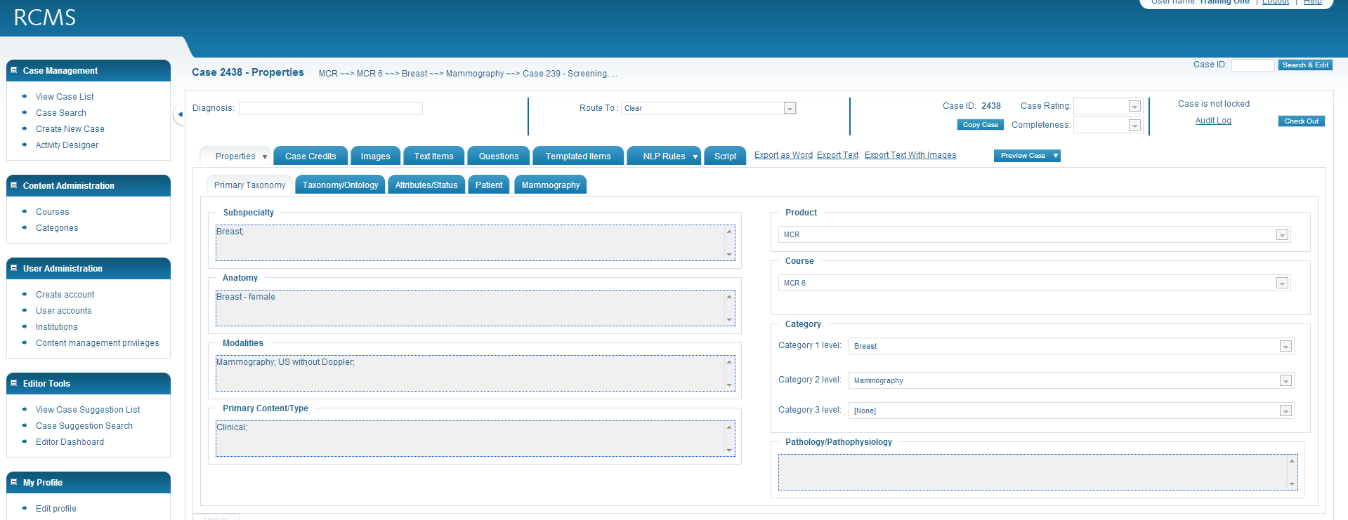

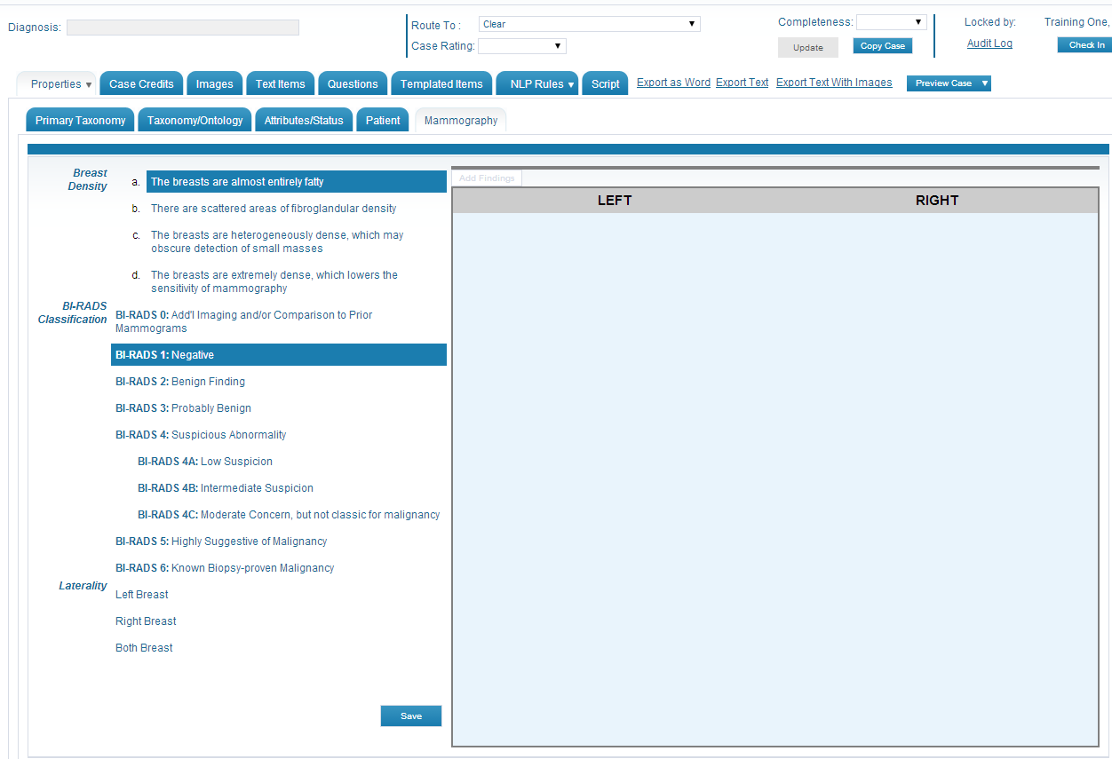

Entering the Case Information

Creating a “Normal” Case or Case with No Findings

- For a case designated as “normal” or no findings on the case, select the breast density and BI -RADS 1 classification. Select [Save] located on the bottom of the screen.

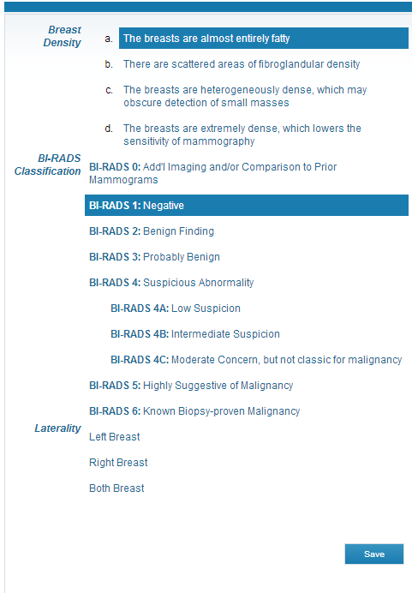

Breast Density, BI-RADS Classification, Case Laterality

- Before any images or findings can be entered for the case, the Breast Density, BI-RADS Classification and Laterality must first be selected. These selections define the case.
- Select the Breast Density by clicking on the appropriate breast composition (a., b., c. or d.). Once selected, the selected option will be highlighted. The option may be changed by clicking on a different breast composition.
- Select the BI-RADS Classification by clicking on the appropriate assessment category. Once selected, the selected option will be highlighted. The option may be changed by clicking on a different BI-RADS classification.
- Select the Laterality by clicking on the Left Breast, Right Breast or Both Breast depending upon where the finding(s) is located.
- Once these three items have been selected, an [Add Findings] button will appear (see red arrow).

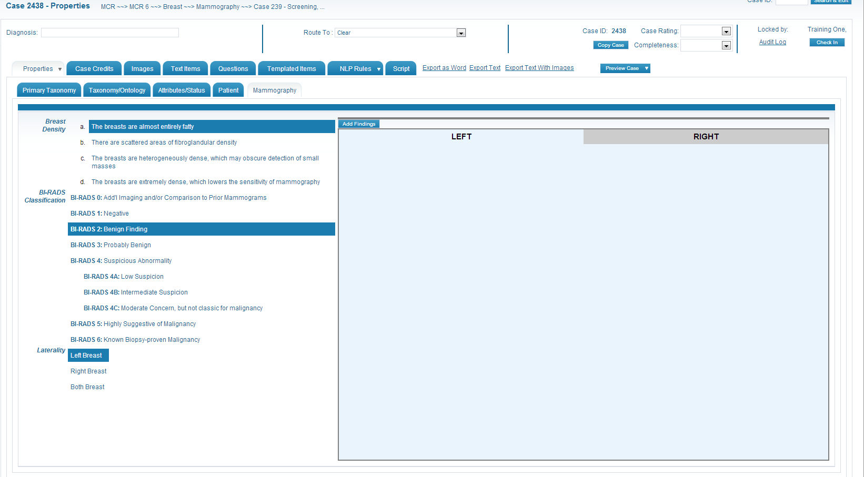
- Select the [Add Findings] button to enter the findings for the case. Once selected, various buttons and options will be displayed.
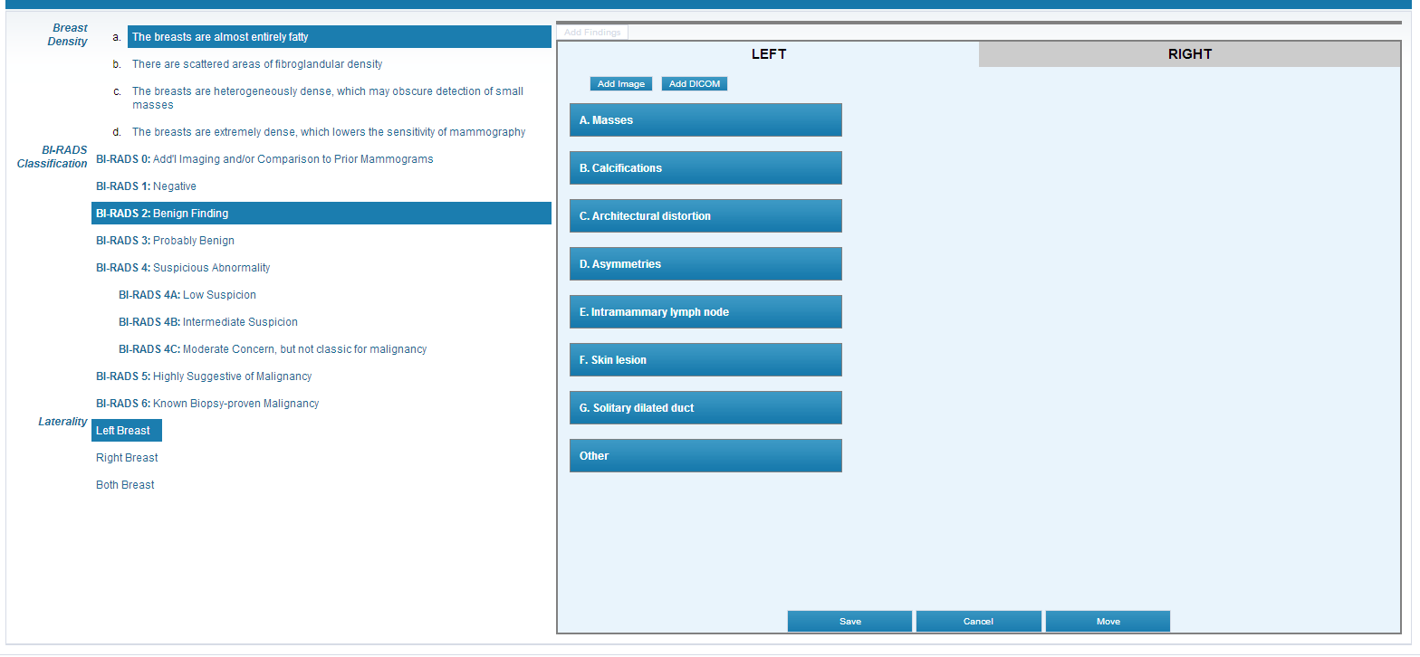

Add Image or DICOM

- Select the [Add Image] button to add a JPEG image to the case. Select the [Add DICOM] to add a DICOM study to the case.
NOTE: Images and DICOMs are selected from the case Image tab. Images and DICOMS must be added to the case on the Images Tab prior to selecting them for the Mammography Tab.
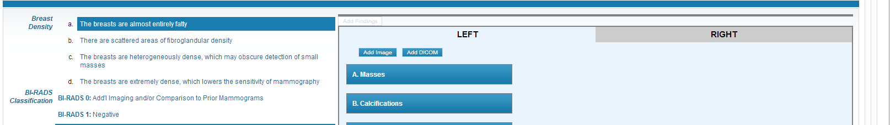
- Selecting the [Add Image] button will open the Image Instance pop-up box. Select the appropriate image(s) using the checkboxes and then select [Insert]. Multiple images may be added.
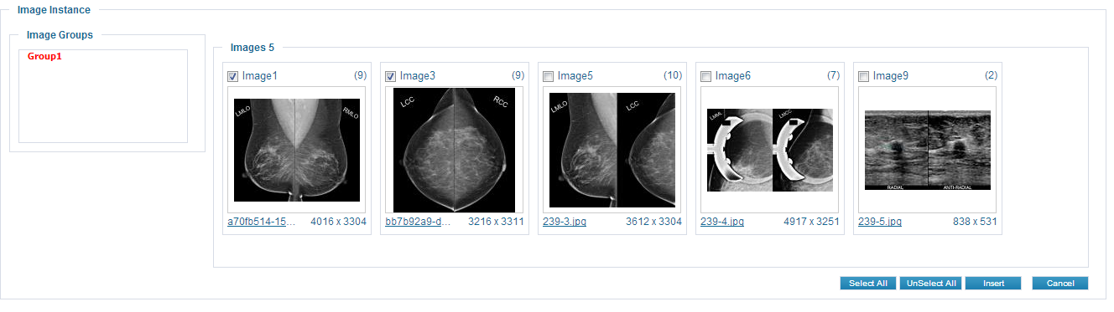
  - Images will then be displayed on the Mammography Tab page.
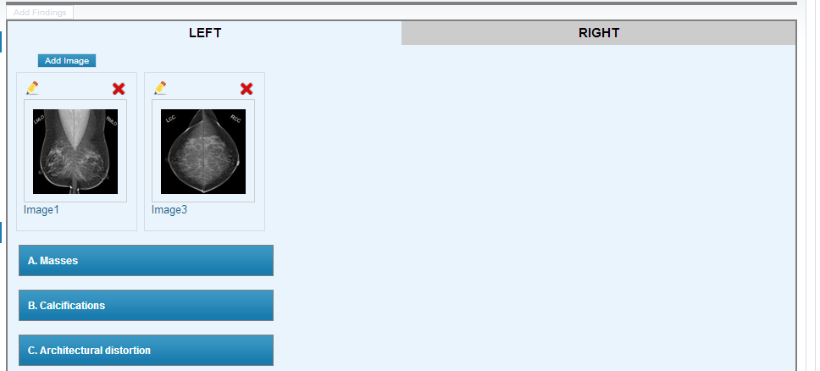
  - Hover the mouse over an image to display a larger pop-up of the image.
  - Select the red X to remove the image from the page.
  - Select the pencil icon to open the IMAPP functionality to map and annotate the image. Refer to IMAPP instructions for mapping and annotating an image.
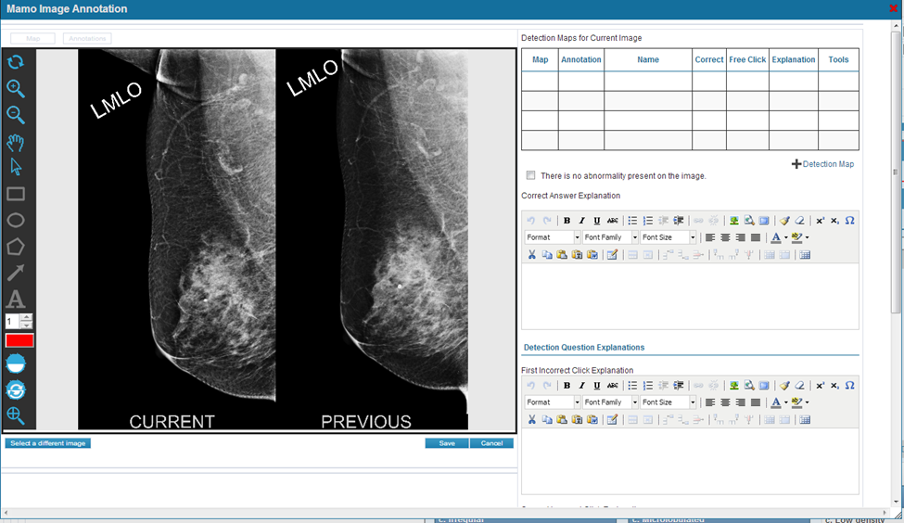

  - To close the IMAPP box, select the red X located in the top right corner.

- Selecting the [Add DICOM] button will open the Image instance box for DICOM studies. Select the appropriate DICOMS(s) using the checkboxes and then select [Insert]. Multiple DICOMS may be added.

  - The DICOM(s) will now be displayed on the Mammography Tab page.
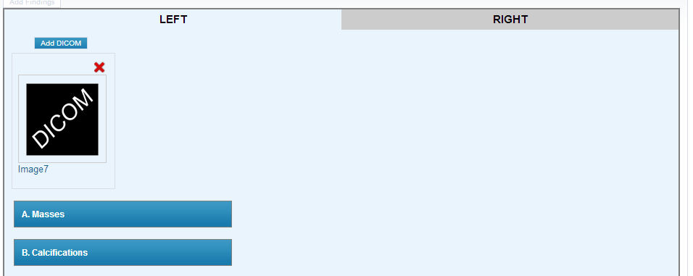
  - Click on the DICOM box to display a larger pop-up of the DICOM study.
  - Select the red X to remove the DICOM from the page.
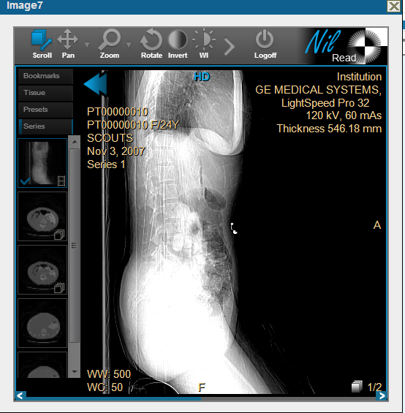
- Once the image(s) or DICOM(s) are added, the finding will be classified.

Add Finding Information

- Select the finding category from the list by clicking on the appropriate category button:
  - Masses
  - Calcifications
  - Architectural Distortion
  - Asymmetries
  - Intramammary lymph node
  - Skin lesion
  - Solitary dilated duct
  - Other – refer to section on use of Other category for more information
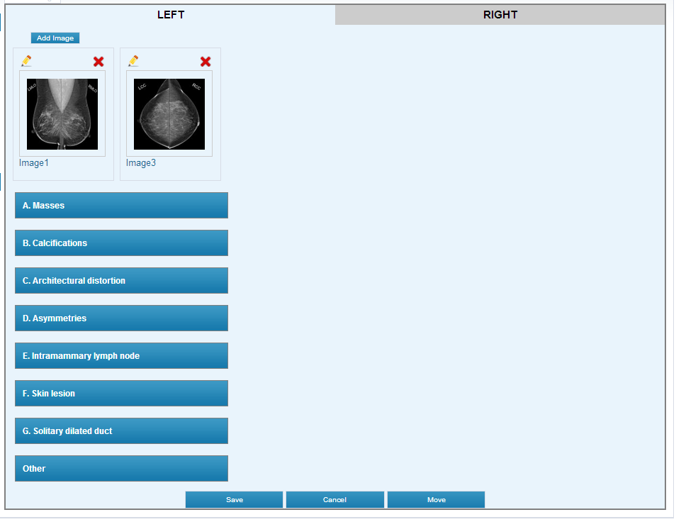
- To change the selected category, click on the (X) next to the category text and choose a new category. Any red X will be used as a delete/remove for the Mammography tab.

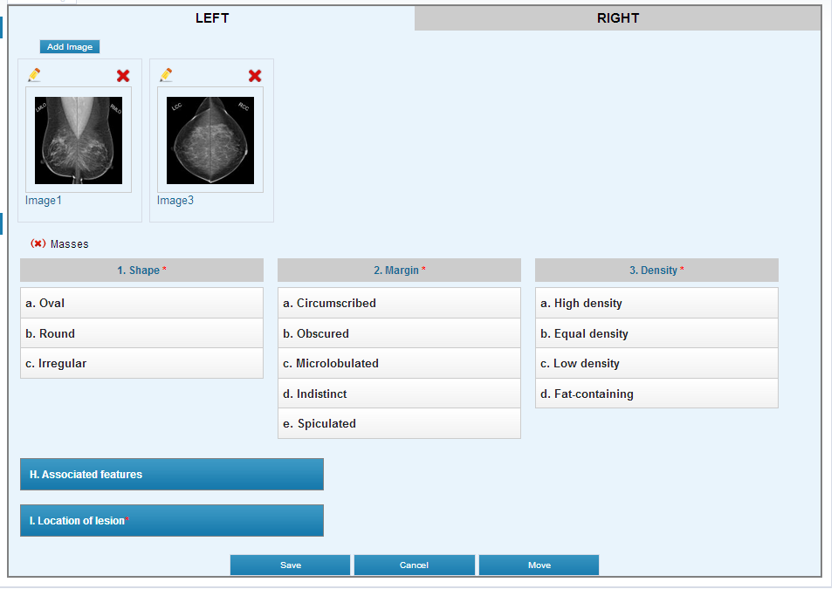

- Once the category is selected, the system will display the various options for that particular category. Each category has required choices as indicated with a red *. A selection must be made for those items. Items without the red *are optional.

- As selections are made for the finding, the selections will be highlighted and displayed in text above. Selections may be changed by either clicking on a new selection or clicking on the red (X) to delete the selection.

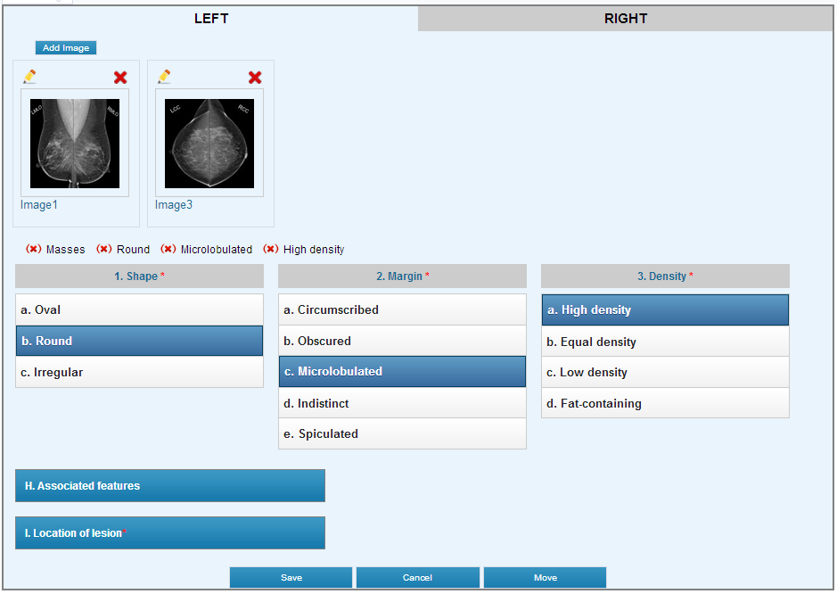

- Associated Features are not required but may be added to a finding to identify other features for a case. Associated features are not available for all categories of findings. Multiple associated features may be selected for a finding. Select the associated feature by clicking on the selection in the list. The selections will be highlighted and displayed in text above. To remove a selection, click on the red (X).

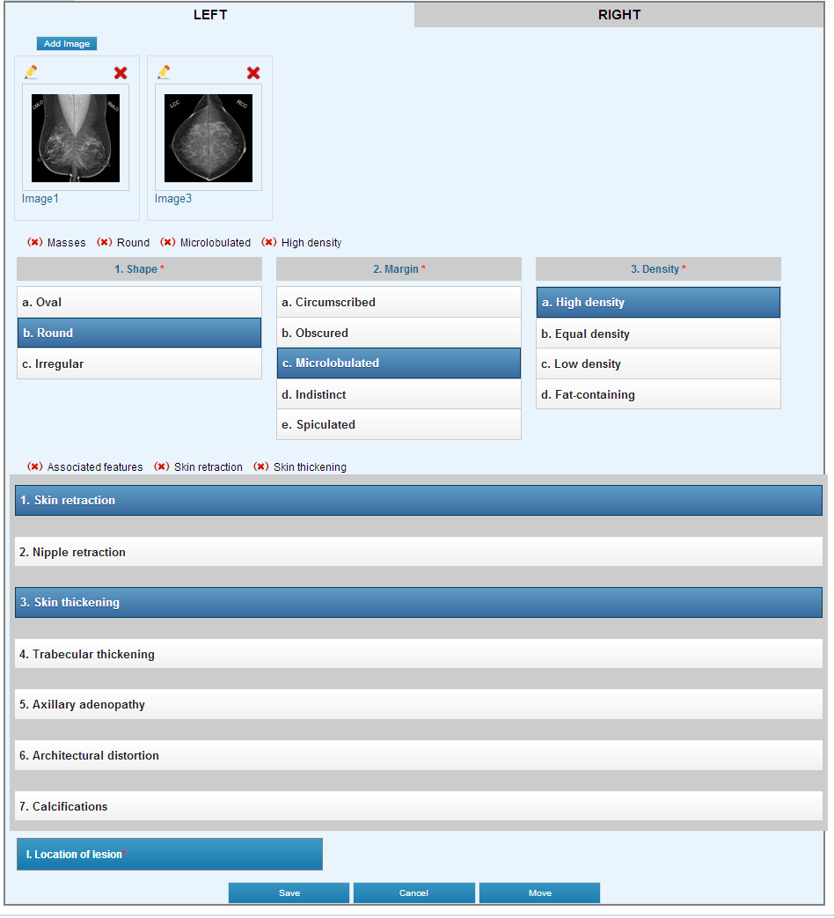

- Location of lesion is a required item for all categories. Click on the Location of lesion button to access the options for this item. Laterality is the only required item for Location of lesion and will be pre-selected based on the Laterality selected previously. Optional items for location are Quadrant, Clock-Face, Depth and Distance from Nipple. When selected, these items will be highlighted or displayed and displayed in text above. To remove a selection, click on the red (X).
  - Quadrant – click on the desired option.
  - Clock-Face – click on the to display the desired option.
  - Depth – click on the desired option.
  - Distance from the nipple – enter a value in the free text field.
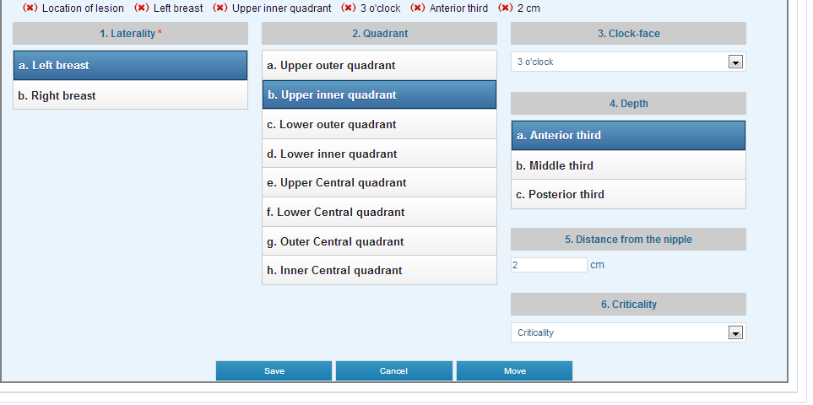
  - Criticality – this is an optional field and may be used to rate the importance of the finding when there are multiple findings for the case. Click on the to display the desired option.

- Once all of the required selections are completed for the finding, select the [Save] button to save the finding information to the case. If required items have not been selected, the system will display an alert to the user at the bottom of the list by the save button. Review the finding and select the missing items.
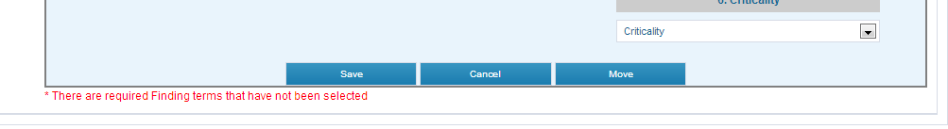
- The saved finding information will now be displayed at the top of the mammography tab page.
  - Select the pencil icon to edit the image, DICOM or finding information.
  - Select the red X to delete the finding from the case.
  - Hover the mouse over the Image1, Image2, etc. to open a pop-up of the image for viewing.
  - Select the copy icon to copy the entire finding information including images/DICOMS to a new finding for that breast laterality. This is useful if you need to annotate a MLO image and describe the Location of lesion and then use the same finding information to annotate the CC image and describe the Location of lesion. Select copy and edit the image and Location of lesion information.

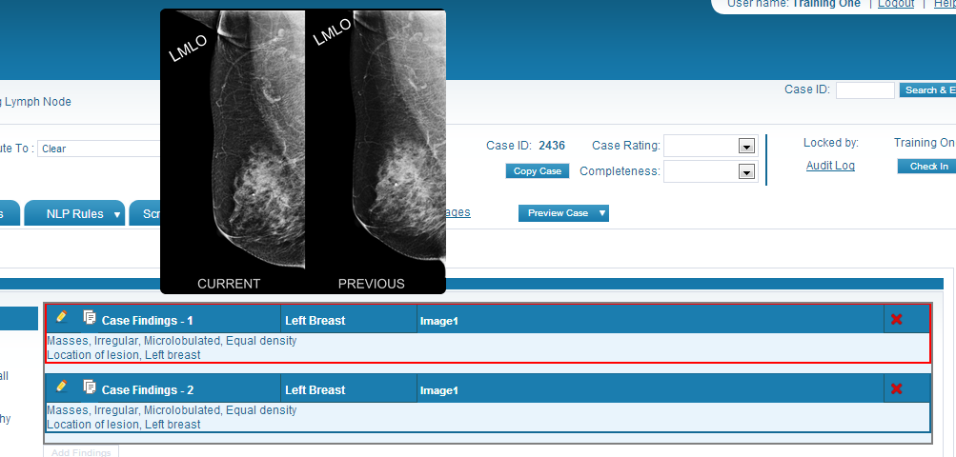
- Additional findings may now be added to the case by selecting the Laterality and then the [Add Findings] button.

Move and Copy Finding Information

- When adding finding information to a case, it may be necessary to either move or copy the information from one laterality to a new laterality. This can be performed in several ways.

Option #1 - Move Finding Information – Changing the Laterality

- In the Location of lesion area, the default laterality will be the laterality selected when defining the case information or the Case Laterality.

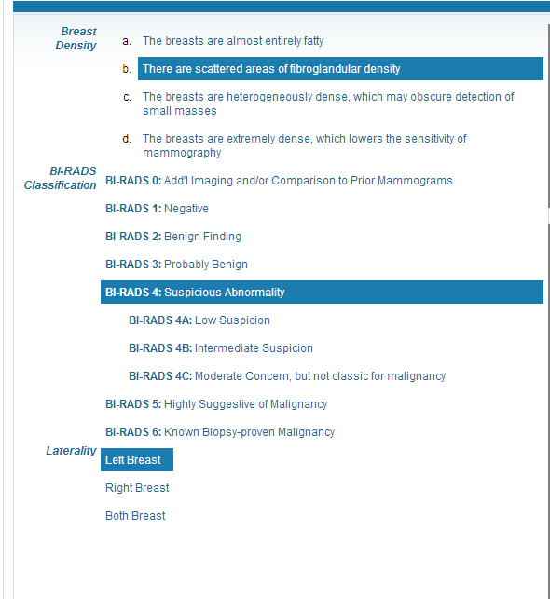
Location of lesion
Case Laterality
- By selecting the opposite laterality, either on the case Laterality or the Location of lesion area, the system will ask if the user wants the finding term information moved from one breast laterality to the opposite breast laterality. Moving the information will remove the finding information from the current laterality and place it under the opposite laterality. NOTE: Image map/annotation and Location of lesion may need to be edited if the findings are moved to a new laterality.

- The system will verify the move with a pop-up confirmation box.
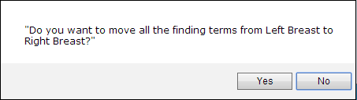

Option # 2 - Move Finding Information – Select the [Move] button

- The same functionality is also available by selecting the [Move] button located on the bottom of the screen. Moving the information will remove the finding information from the current laterality and place it under the opposite laterality. NOTE: Image map/annotation and Location of lesion may need to be edited if the findings are moved to a new laterality.

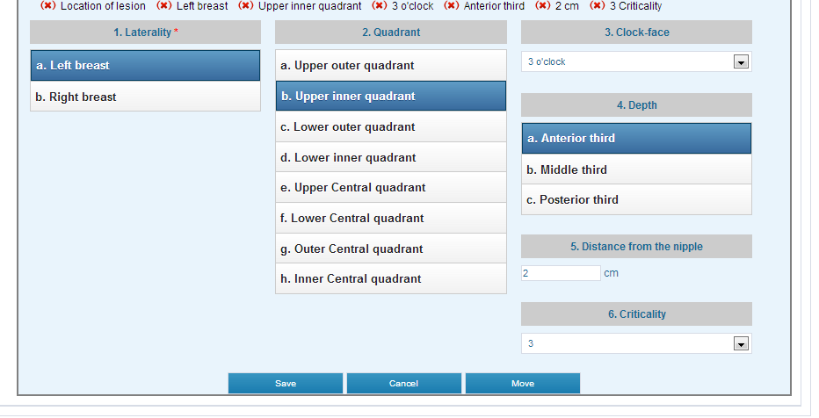
- The system will verify the move with a pop-up confirmation box.
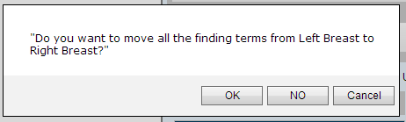

Option # 3 - Copy Finding Information – Changing the Laterality

- In some instances, there may be similar findings on both breasts. There is copy functionality available to copy finding information from one breast laterality to the opposite breast laterality.

- If finding information has been started for either the Left Breast or Right Breast laterality, to copy the information, select Both Breasts for the Case Laterality. The system will ask the user if the finding terms are to be copied to the opposite breast laterality. Copy will retain the information on the original laterality and place the same information on the opposite laterality.

NOTE: Although possible, the finding terms for both breasts will not be exactly the same. Edit any finding information, especially the Location of lesion and any Image map/annotation as applicable for each breast laterality.

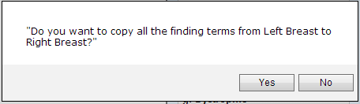

Option # 4 - Copy Finding Information – Select the [Copy] Button

- If the case is known to have similar findings on both breasts, select Both Breast as the Case Laterality. The system will default to the Left Breast. Define the finding information for the Left Breast and then select the [Copy] button located at the bottom .
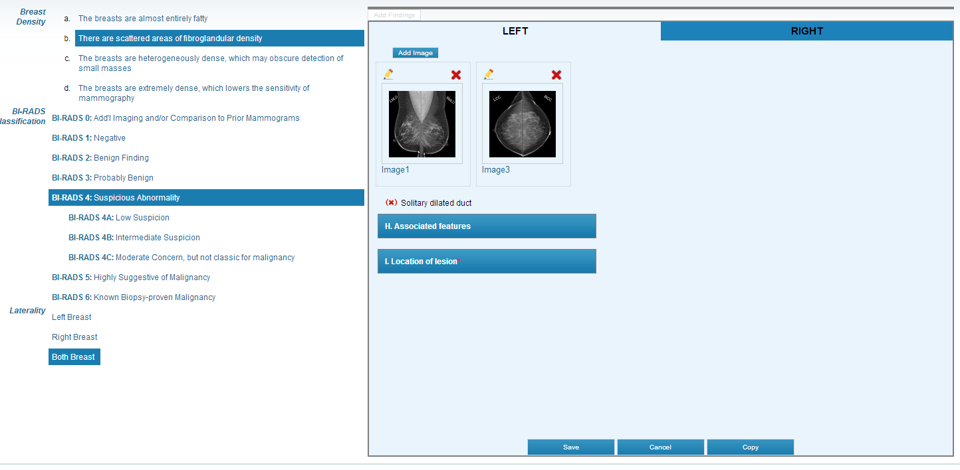
- The system will ask the user if the finding terms are to be copied to the opposite breast laterality. Copy will retain the information on the original laterality and place the same information on the opposite laterality.

NOTE: Although possible, the finding terms for both breasts will not be exactly the same. Edit any finding information, especially the Location of lesion and any Image map/annotation as applicable for each breast laterality.

Option # 5 - Copy Saved Finding Information – Select the [Copy] Icon

- There may be cases where you want to copy a saved finding. Select the “copy” icon by the saved and the system will create a new finding using the same information in the saved finding.

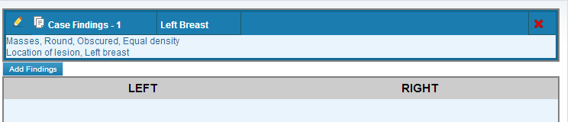

Use of Other Category

- Listed on the Findings area of the Mammography tab is an option for [Other]. This feature is not a BI-RADS finding but allows the user to designate some feature or observation on an image.
- Add an image to the finding and map/annotate the image for the feature/observation. An explanation can be added to identify the feature or observation on the IMAPP box. Select the checkmark for “There is no abnormality present on the image.”
- On the Findings area, select the [Other] option. Location of lesion may also be defined. Select [Save] to save the feature.

IMAPP – Mapping and Annotating an Image

NOTE: DICOM studies do not use the IMAPP functionality.
IMAPP allows the user to map and annotate and image. Mapping identifies the co-ordinates for an area on the image which can then be used for detection type questions for the case. The “map” is used to determine if the user is selecting the correct or incorrect area of the image based on the detection question co-ordinates. The user is also allowed to annotate the image. Annotation allows the user to draw a visual cue on an image. This visual cue will help the user display an area on the image.
- Once an image is added to a finding on the tab, select the pencil icon . This will open the IMAPP in a new box.
- The IMAPP box may be resized by using the on the bottom right corner of the box.
- The user may also drag the box by placing the mouse on the blue banner on the top of the box, left click and hold. The mouse will change and allow the user to drag the box around the screen.
- Select the red X on the top right of the box to close the IMAPP box.
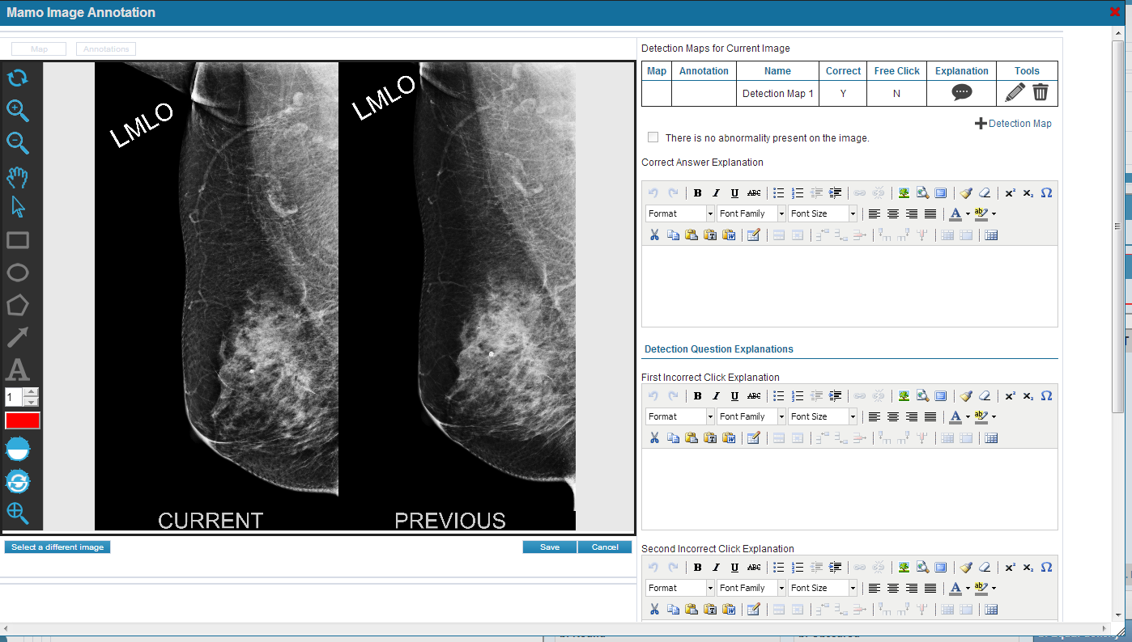

- Mapping / annotating an area:
  - To map an area on the image, select the pencil icon under the tools column header for the Detection Maps for Current Image grid.
  - When selected, the grid will be outlined in red, indicating that particular detection map is selected for editing.
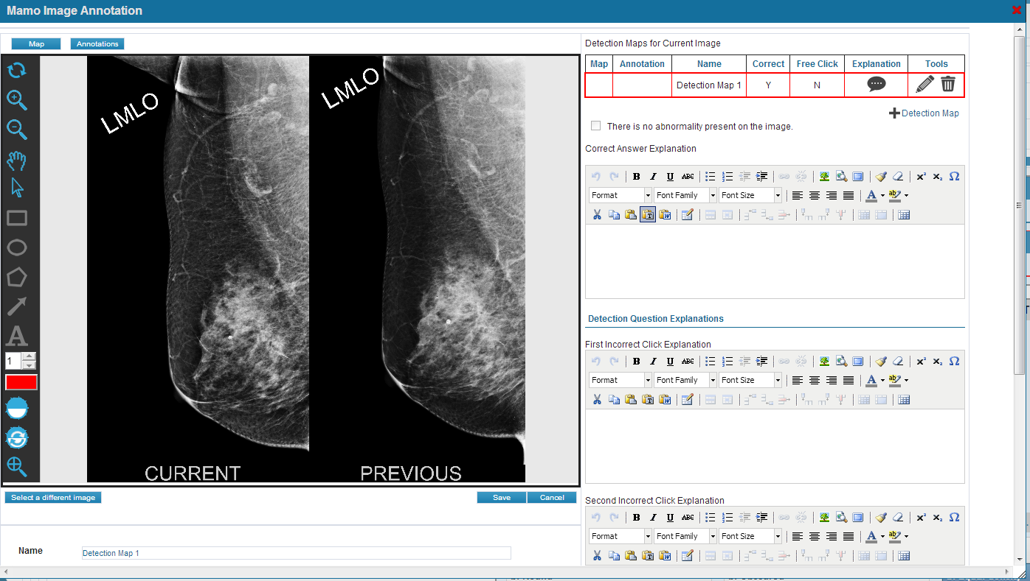
  - Select the [Map] button located to the top left above the image (see screenshot above). The pointer tool (arrow) is now active. Using the pointer tool, select one of the available shapes. The shape icon will be highlighted and the pointer is changed to a cross +. Place the cross on the image to be mapped, left click and drag the mouse to draw the shape on the image.

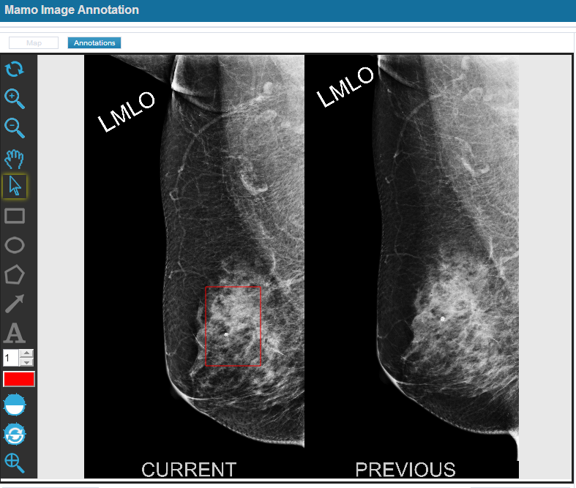

  - To edit or delete the shape, use the pointer tool to click on the shape. Edit functionality is now active indicated by boxes and circles on the shape. To delete, use the [Delete] key on the keyboard.
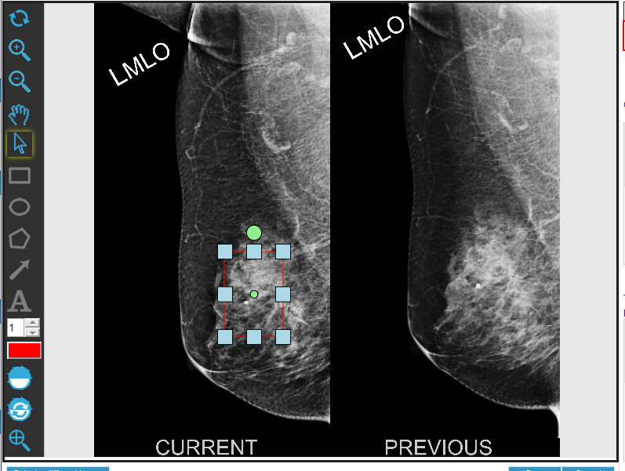
  - The map can be resized by clicking on any of the square boxes and dragging the mouse.
  - Changing the color of the map as well as the thickness of the shape lines can also be done. Select the color box to open the choices, select the color and then select the [Apply] button. The shape will now be displayed in the selected color. Using the up/down arrows next to the number will change the thickness of the shape line.
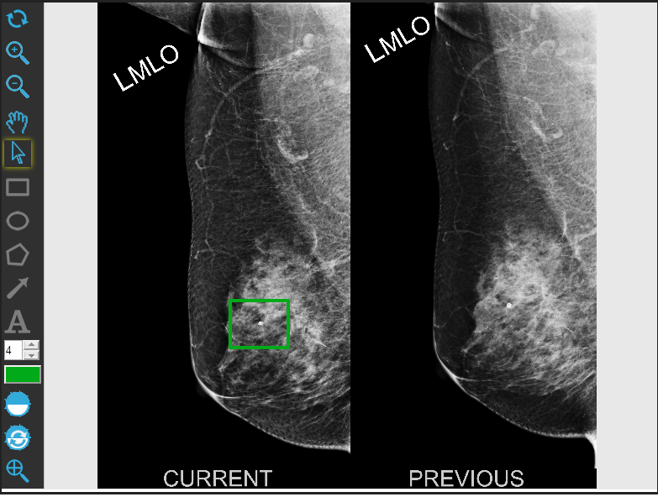
  - To annotate the image, select the [Annotations] button located on the top left above the image. The same functionality to add a map is used to annotate. Select a shape to add to the image and edit the shape.
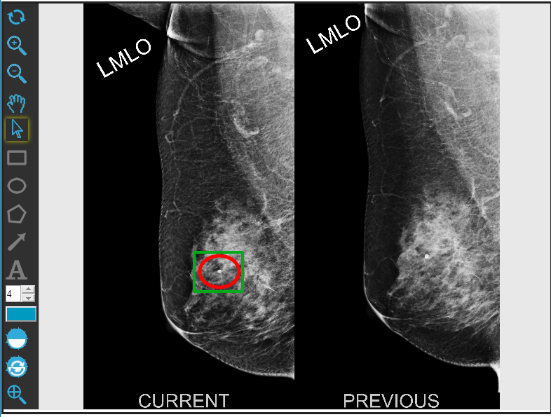
  - Annotate has two additional features. The user is able to add arrows and comment box as annotations.
  - Once the image is mapped and/or annotated, select the [Save] button located below the image to save the detection map. The system will indicate the save was successful and the buttons for [Map] and [Annotations] will now be turned off.
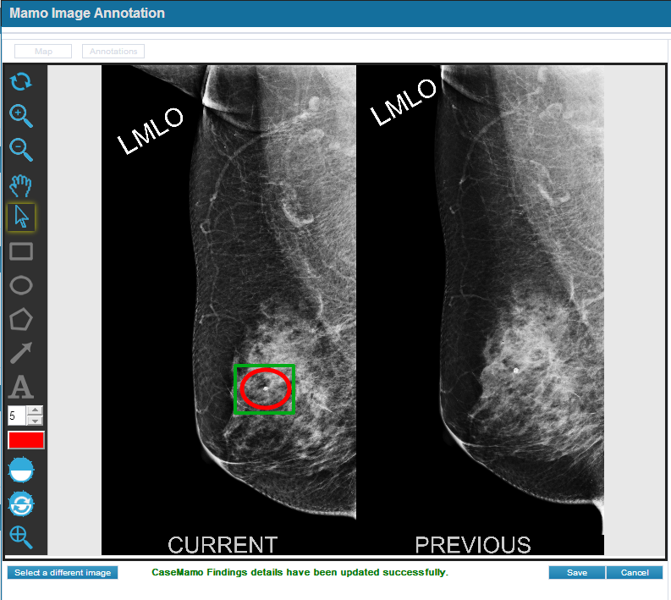
  - The user may now add a new detection map / annotation to the image by clicking on the + Detection Map located below the Detection Map grid.
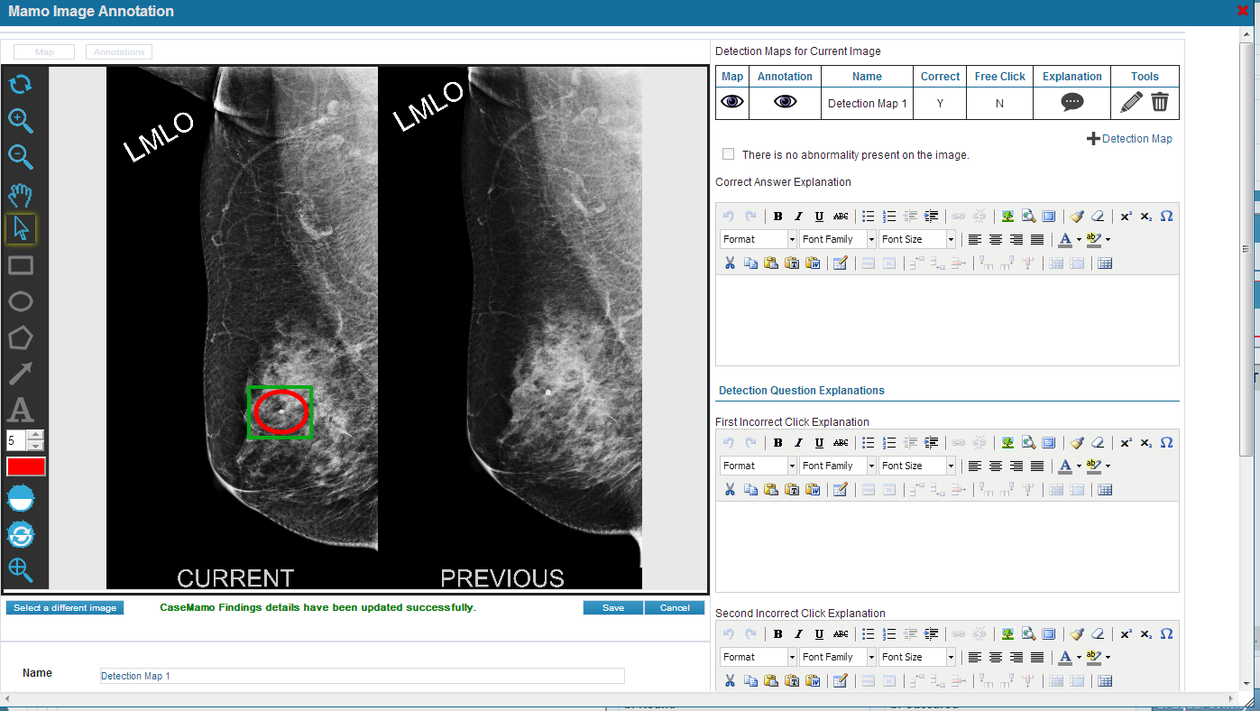

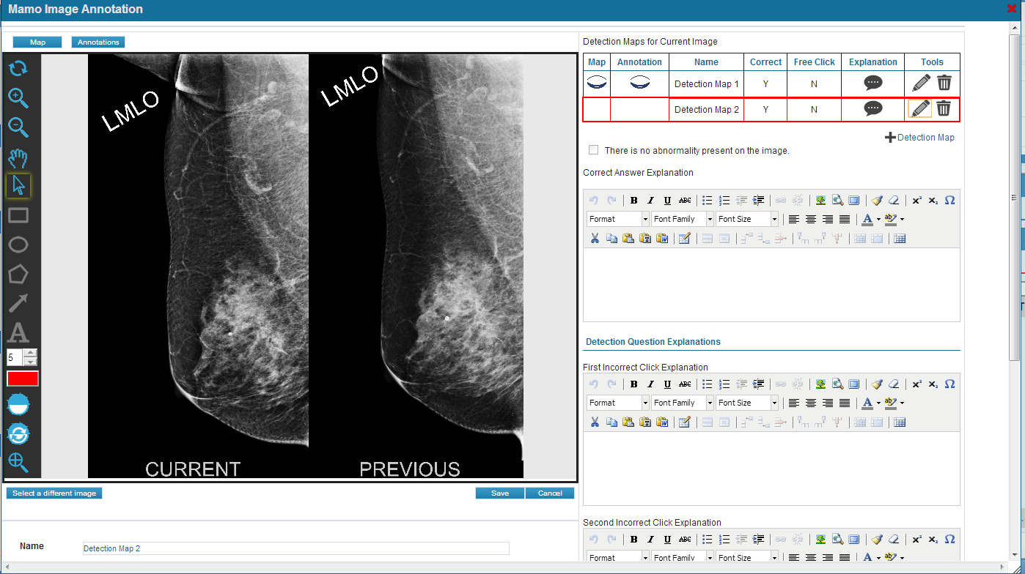

- Additional features for the IMAPP:
  - View / Hide the map and annotation (eye icon ) – click on the eye icon under the Map and Annotation column of the grid to view or hide the map/annotation on the image.
  - Zoom on image – use the magnifying glass icons to zoom in or zoom out on the image. Use the circular arrows to reset the zoom.

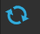

  - Hand icon – when zoomed in on the image , the hand icon allows the user to grab and drag the image around.
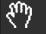

  - Adjust Contrast and Brightness – select the contrast icon then left click and scroll up/down to increase or reduce the contrast/brightness. Select the reset icon to change back to the default setting. NOTE: This functionality is not fully supported by LEAD Tools and may not function with large images.

  - Magnify – magnifier icon with cross lines allows the user to magnify an area of the image without zooming in on the entire image. Select the magnifier icon and left click on the image. A small magnified box will appear that can be moved over the image.

